Assignment 3
File persistence
In this assignment you will expand your app to save data in files. This way, data is saved even when the app is restarted. The content of the files will be in json format.

Status
Last time you implemented a command line user interface.
Your application should look something like this:
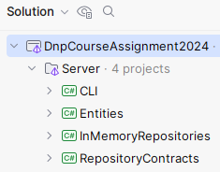
Or as a component diagram, we can show it like this:
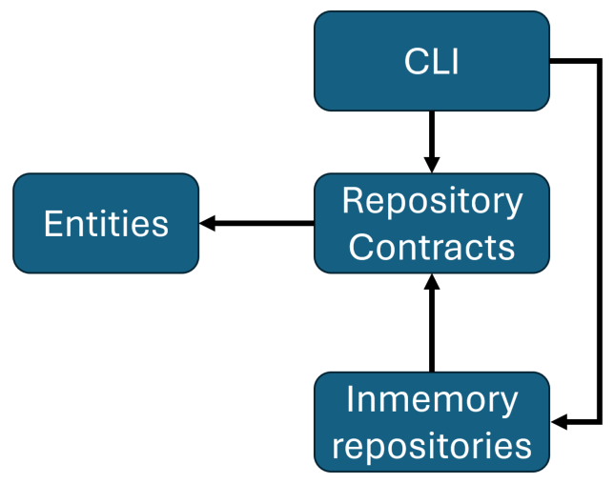
The arrows indicate dependencies between projects.
We will expand with a new project, to contain new implementations for the repository interfaces. This time using files to store data, so that the data is actually persisted between sessions of the application running.

Setup
Again, we need a new project, this time for the new, improved, better repository implementations.
Create a Class Library project, on the Server side.
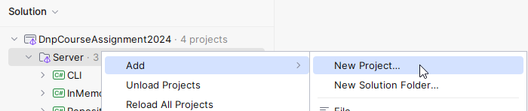
And then:
- Select Class Library.
- Give the project a meaningful name.
- Make sure the project is located in Server
- Pick SDK, language, framework, if possible.
- And create the project.
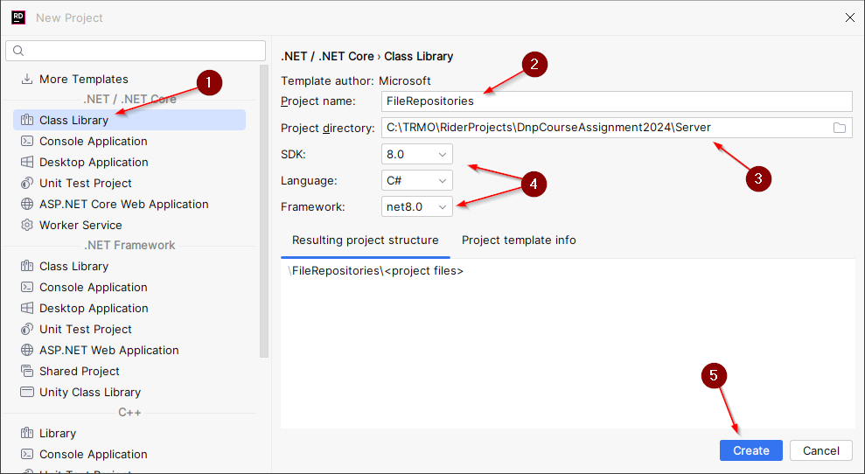

As usual, delete the Class1.cs.
And do git version control.

Dependencies
Your new FileRepository project needs to have dependencies to:
- RepositoryContracts
- (Entities, though this automatically happens through RepositoryContracts. It is a transitive dependency)
Your CLI needs a dependency to your FileRepositories.

Now your component diagram looks like this:
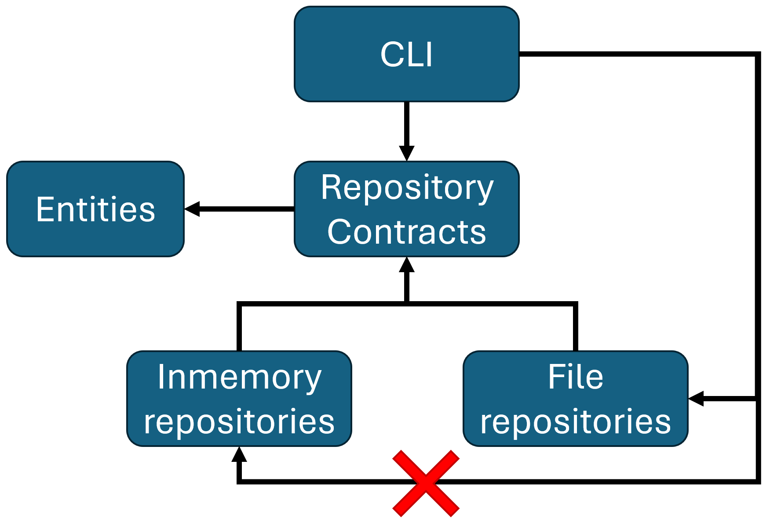
The red X indicates this dependency is no longer needed, after the completion of this assignment.

File Repository Implementations
Inside your new project, you must create an implementation for each of the repository interfaces.
You will not have a private field variable of some list containing entities. Instead, this ”list” is represented by the file.
Each method must then, as needed, do:
- Read the text (json) from the file.
- Deserialize json-text into a list.
- Interact with this list, e.g.:
  - Add new entity.
  - Retrieve entity.
  - Delete entity.
  - Overwrite entity.
- Serialize the list to json.
- Write the json back to the file, overwriting the existing content.
You should use the async file interaction methods: ReadAllTextAsync, WriteAllTextAsync, etc.
I provide below an example of the AddAsync method. The others are similar in the way they use json and the file to get a list, and the list is then used similar to the InMemory versions:
- public class CommentFileRepository : ICommentRepository
- {
- private readonly string filePath = "comments.json";

- public CommentFileRepository()
- {
- if (!File.Exists(filePath))
- {
- File.WriteAllText(filePath, "[]");
- }
- }

- public async Task<Comment> AddAsync(Comment comment)
- {
- string commentsAsJson = await File.ReadAllTextAsync(filePath);
- List<Comment> comments = JsonSerializer.Deserialize<List<Comment>>(commentsAsJson)!;
- int maxId = comments.Count > 0 ? comments.Max(c => c.Id) : 1;
- comment.Id = maxId + 1;
- comments.Add(comment);
- commentsAsJson = JsonSerializer.Serialize(comments);
- await File.WriteAllTextAsync(filePath, commentsAsJson);
- return comment;
- }
Explanations:
Line 3: Here we define the file path. We create a file per entity.
Line 5-10: The constructor ensures there actually is a file. If none exists, e.g. the first time the program is run, a new file is created, with the content of an empty list, i.e. no entities. The ”[ ]” is an empty collection in json.
Line 13 is the method header, again asynchronous, returning a Task containing the ”finalized” comment, i.e. it now has an ID.
Line 15: We read all the content from the file, this is of course in json format.
Line 16: The json i deserialized into a list of comments.
Line 17: We calculate the next Id to use.
Line 18: Set the Id.
Line 19: Add the comment to the list.
Line 20: Serialize the list to json.
Line 21: Write the json back to the file.
Line 22: Return the finalized comment, now it has an Id.

Hint: I have afterwards extracted the loading and saving to helper methods, to minimize code duplication.

GetMany detail
Sometimes, you may not be able to await a Task. Instead you can call Result on a task, as in the first statement, at the end:
public IQueryable<Comment> GetMany()
{
string commentsAsJson = File.ReadAllTextAsync(filePath).Result;
List<Comment> comments = JsonSerializer.Deserialize<List<Comment>>(commentsAsJson)!;
return comments.AsQueryable();
}
ReadAllTextAsync() returns a Task containing a string. Calling Result, instead of awaiting, will extract the string. This is generally not advisable, because we loose the async behaviour and optimization, but in this case the method header is not async, as defined in the interface, so we have to ”cheat”.
Again, the lack of async on this method is made clearer when we get to the database part.

Update CLI project
Your CLI project must now use the new repositories instead of the InMemory versions.

Add reference to FileRepositories
Add a reference from CLI project to FileRepositories project, so your CLI app can use the new repositories (if you didn’t do this above).

Remove reference to InMemoryRepositories
The easiest approach to make sure you update all references to the InMemory repositores, is to delete the dependency reference from CLI project to InMemoryRepository.
You do this by editing the CLI.csproj file.
Go to File System view:
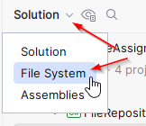
Find the CLI.csproj file:
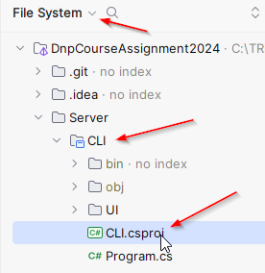
Delete the reference to the InMemoryProject.
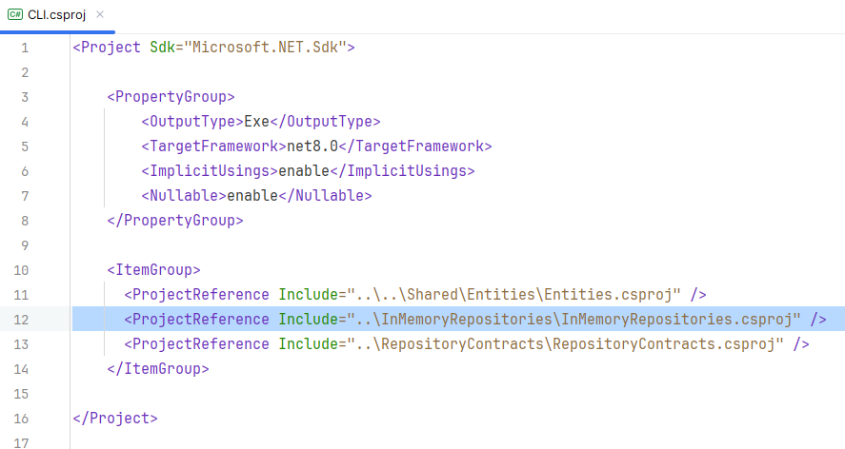
Go back to solution view.
Watch your CLI project fail to compile now. All errors are where you are referencing a repository implementation. Not the interface, those live in a different project, the RepositoryContracts.

Update repository implementation references
Each place where you reference an implementation, e.g. PostInMemoryRepository, you must change the class to PostFileRepository. Hopefully you only need to modify about three lines of code in the CLI/Program.cs class.
Notice I instantiate file repositories here instead:
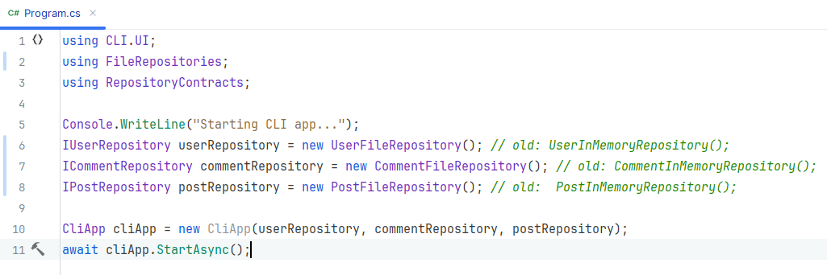

Formalities
You may work on this assignment in groups.
You must have your assignment on GitHub.
You must hand in a link to the specific GitHub file-repository-folder on itslearning, like this:
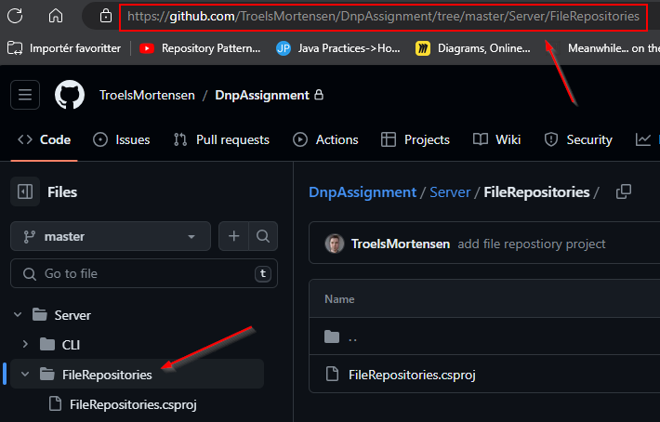
Deadline can be found on itslearning.

